SET - 1
Regulations:
A17

H.T No

Sreenidhi Institute of Science and Technology
(An Autonomous Institution)
Code No: 6B202 Date: 07-June-2018 (FN)

B.Tech I-Year II-Semester External Examination, May/June - 2018 (Regular)
ENGINEERING DRAWING – II (CIVIL and ECE)

Time: 3 Hours Max.Marks:75

Note: a) No additional answer sheets will be provided.
b) All sub-parts of a question must be answered at one place only, otherwise it will not be valued.
c) Missing data can be assumed suitably.

Part - A Max.Marks:25

Answer all QUESTIONS.

1. | What is a Vernier scale? Give its applications | [3M]
2. | Briefly explain about “Parallel Line Method” of development of surfaces. | [3M]
3. | Draw the isometric view of a hexagonal plane of side 40 mm and whose surface is parallel to VP and two sides perpendicular to HP. | [3M]
4. | Explain about “Box Method” used in drawing isometric views. | [3M]
5. | Define the term perspective projection. Give its applications. | [3M]
6. | Explain the commands required to create and copy a point in AUTOCAD. | [2M]
7. | Define Representative Fraction in Engineering Scales. | [2M]
8. | How the knowledge in development of surfaces is helpful in fabrication of sheet metal? | [2M]
9. | Construct the isometric scale. | [2M]
10. | Explain the terms Ground Plane (GP) and Station Point (SP) used in perspective projections. | [2M]

Part – B Max.Marks:50
ANSWER ANY FIVE QUESTIONS. EACH QUESTION CARRIES 10 MARKS.

11. |  | A rectangular piece of land of area 0.54 hectares is represented on a map of 3cm x 2cm. Calculate the R.F and draw a diagonal scale to read up to one meter and long enough to measure up to 500 metres. Mark a distance of 456 metres on it. | [10M]
12. |  | A cylinder of base diameter 60 mm and axis 80 mm is resting on ground with its axis vertical. It is cut by a section plane perpendicular to VP and inclined at 45⁰ to HP and bisecting the axis. Draw the development of its lateral surface. | [10M]
13. |  | Draw the isometric view of a pentagonal pyramid of base 30 mm and axis 60 mm when (i)The pyramid is kept on its base on the HP.  (ii) The pyramid is kept on its base in VP. | [10M]
14. |  | 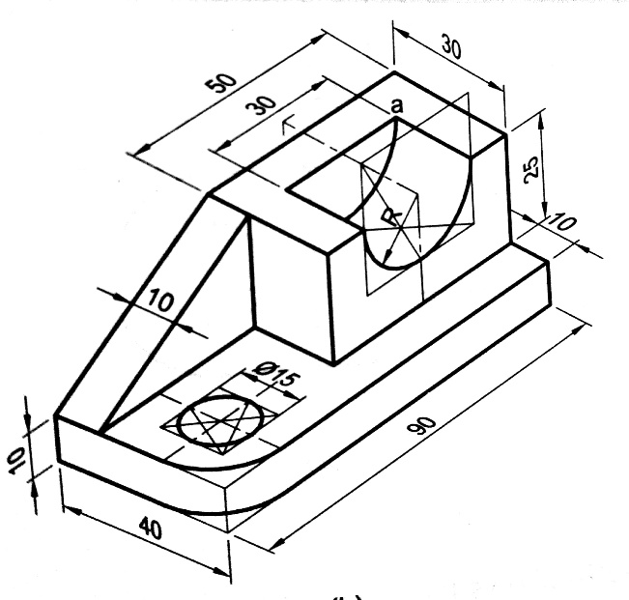  Draw the orthographic projections of the isometric view shown in the figure.  X | [10M]
15. |  | A square pyramid of base side 40 mm and axis 60 mm long rests on the GP with an edge of the base parallel to and 15 mm behind the PP. The station point is 90 mm above GP and 75 mm in front of the PP and lies in a Central Plane which is 40 mm towards the right of the axis of the pyramid. Draw its perspective projection. | [10M]
16. |  | Define the term, “Computer Aided Drafting”. Discuss its significance and applications in modern engineering practice. | [10M]
17. |  | A square pyramid of base side 40 mm and axis 60 mm is resting on its base on HP such that a side of base is parallel to VP. It is cut by a section plane perpendicular to VP and inclined at 45⁰ to HP and bisecting the axis. Draw the development of its lateral surface. | [10M]
18. |  | Draw the orthographic projections of the isometric view shown in the figure.  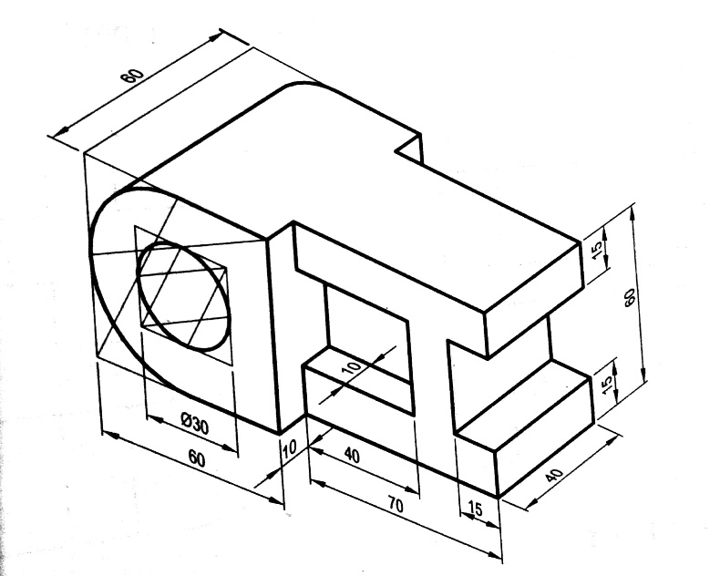  X | [10M]
-- 00 -- 00 –

